# Exercise 1

Create a script that contains the formula for converting Fahrenheit to Celsius.

Create a variable named fTemp that represents a Fahrenheit temperature. Assign the value 86 to the variable.

Output the Celsius value onto the page using the write() method with an appropriate message.

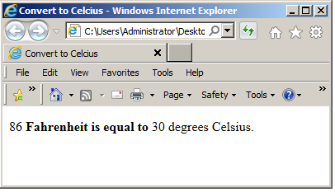

**Exercise 2**

Many companies normally charge a shipping and handling fee for purchases. Create a script that calculates shipping and handling based on a value assigned to a variable called purchase.

A minimum shipping and handling fee of 1.50 is added for any purchase less than or equal to 25.00. For a purchase over 25.00, add 10% to the total purchase price but do not include the 1.50 minimum shipping and handling fee.

The formula for calculating a percentage is price * percent /100. Use the comparison and conditional operators for this exercise.

After you have calculated the total cost of the order display it in an alert dialog box.

Purchase price of 24 euros gives you 25.50

Purchase price of 60 euros gives 66.00

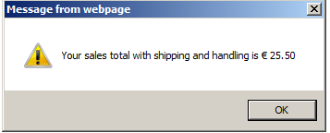

To convert a number to a string value with a specific number of decimal places you can use the toFixed() method.

Example salesPrice.toFixed(2) will output the salesPrice as a string correct to 2 decimal places. More on these methods in a later class.

**Exercise 3**

Given the formula for the volume of a cylinder, V, as V = πr2h

where r is the radius and set to 5 and h the height and set to 6 of the cylinder and taking π as 3.142 , write a script to calculate and display its volume based on the formula given above .

